**Name: Date:**

# Sugar Cube Weathering

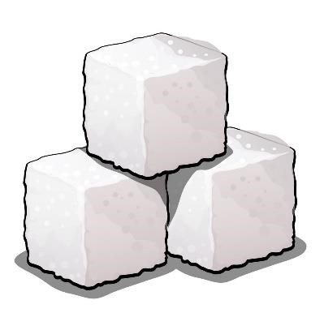**Physical weathering is the process of breaking rocks into smaller pieces without any chemical change. It can be caused by abrasion from wind-blown sand, abrasion from water rolling rocks against each other, temperature changes from the sun**’s heating**, or living things (roots growing in cracks).**

**Procedure**

1. **Draw the shape of the sugar cube in the box marked** “before”**.**
2. **Place sugar cube into the jar and close jar.**
3. **Shake vigorously for 1 minute.**
4. **Open jar and observe the current state of the cube.**
5. **Draw the cube and the particles in the** “**after**” **box.**

**Prediction/Hypothesis**

**What will happen to the sugar cube if it is shaken vigorously in a glass jar?**

**Observations**

**BEFORE AFTER What does the sugar cube represent?**

**When you simulate something, it is called a model. What real-world environment did this experiment model?**

**Was the prediction you made at the beginning of the experiment correct? Yes or no?**

**Look at the loose sugar in the jar. Sugar was broken from the cube and is resting at the bottom of the jar. What part of the environment do the deposits represent? Circle one.**

**Soil Rocks Ice**